**(2) PROJECT: LINKED LIST IMPLEMENTATION**

**Naveen**

**UNIVERSITY NAME:**

**Advanced Algorithm**

**INSTRUCTOR NAME:**

**DATE OF SUBMISSION:**

# Answers

## Answer 1

I spent around two and a half hours on this assignment.

## Answer 2

I would say I earned an A based on my effort.

## Answer 3

I would say I earned an A based on my solution.

## Answer 4

Everything in my code works properly. The greatest challenge was to implement the linked list of sparse matrices. I spent more time to learn how pointers are used because I struggled to come up with the node structure using row, column, value and the pointer to the next node. After knowing how to use the pointer correctly, the rest of the code became less difficult to complete.

# Code and Output

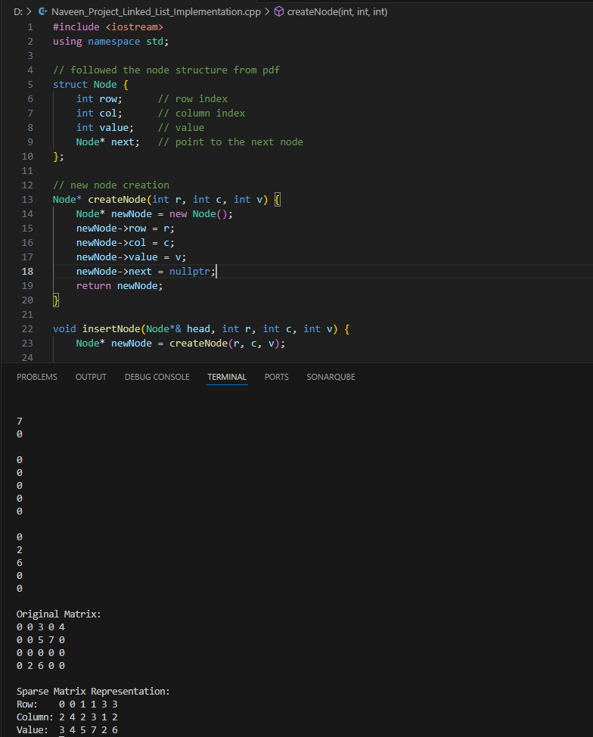

Figure 1: Screenshot of Code and Output

GitHub Link: